Blog Listing Component

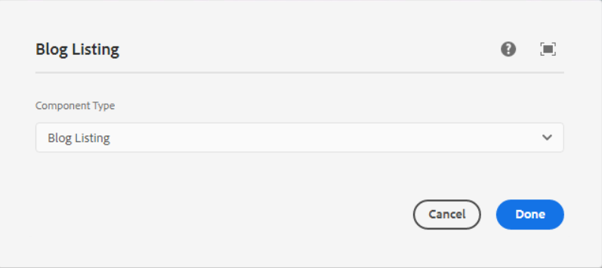

In this dropdown below list of component types are available, we can select one type as per our requirement.

1. **Blog Listing** - This component will use in blog listing page.

**Page Reference** - <https://www.ancestry.com/corporate/blog>

**AEM URL** - <https://author-ancestry-dev2.adobecqms.net/content/ancestry-corp/us/en/blog.html?wcmmode=disabled>

In this component, below list of fields are visible

* **Search Box** – Here we can search any blog as per the requirement
* **Year and month filter dropdown** – Able to find any blog using year and month
* **Blog listing section** – When we create a new blog using a blog template then that blog will be shown here and also the list of blogs visible.
* **Pagination** – Using pagination we can able to see all the blogs while clicking on the pagination number.

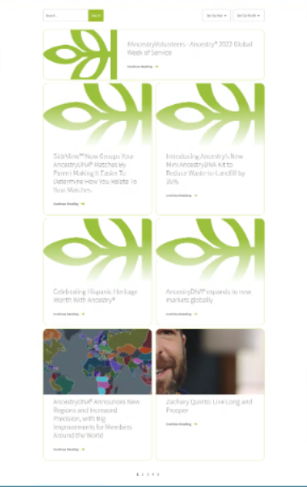

___________________________________________________________________

1. **Featured Blog (Homepage) -** This component will use in Homepage.

**Page Reference -** <https://www.ancestry.com/corporate/>

**AEM URL** - <https://author-ancestry-dev2.adobecqms.net/content/ancestry-corp/us/en.html?wcmmode=disabled>

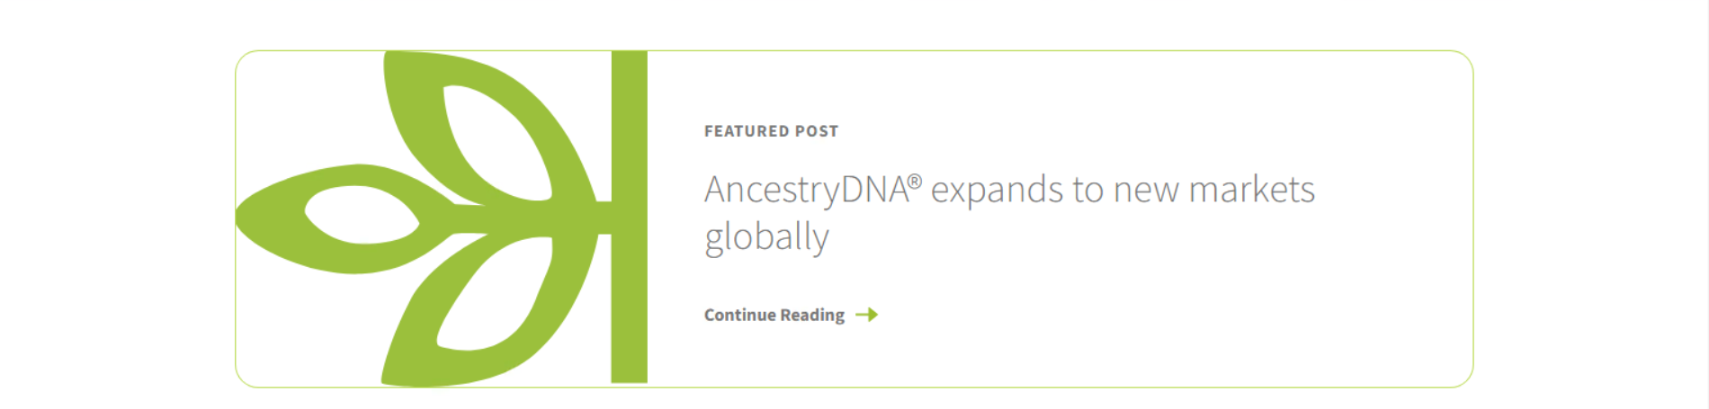

Only one blog we can able to show as a Featured blog on the homepage, and we need to set the property for that blog as the Homepage position is 1 as per the below screenshot.

